AI DRIVEN RESUME
SCREENING SYSTEM

A
Minor Project Report
Submitted in partial fulfillment of the requirement for the award of degree of

Bachelor of Technology
In
Computer Science & Engineering

Submitted to
RAJIV GANDHI PROUDYOGIKI VISHWAVIDYALAYA,

BHOPAL (M.P.)

Guided by Submitted By
Prof. Sumeet Kothari Saransh Patil 0832CS221182
Tushar Gawhade 0832CS221213
Vivek Rathore 0832CS221228
Yash Lade 0832CS221229

DEPARTMENT OF COMPUTER SCIENCE & ENGINEERING
CHAMELI DEVI GROUP OF INSTITUTIONS
INDORE (M.P.) 452020 2024-25

AI DRIVEN RESUME
SCREENING SYSTEM

A Minor Project Report submitted to
Rajiv Gandhi Proudyogiki Vishwavidyalaya, Bhopal
Bachelor of Technology
in
Computer Science and Engineering

by

Saransh Patil 0832CS221182
Tushar Gawhade 0832CS221213
Vivek Rathore 0832CS221228
Yash Lade 0832CS221229

Under the guidance of

Prof. Sumeet Kothari
Assistant Professor


Session: 2024-2025
Department of Computer Science & Engineering
Chameli Devi Group of Institutions, Indore

452020 (Madhya Pradesh)

DECLARATION

We certify that the work contained in this report is original and has been done by us under the guidance of my supervisor(s).
- The work has not been submitted to any other Institute for any degree or diploma.
- We have followed the guidelines provided by the Institute in preparing the report.
- We have conformed to the norms and guidelines given in the Ethical Code of Conduct of the Institute.
- Whenever we have used materials (data, theoretical analysis, figures, and text) from other sources, we have given due credit to them by citing them in the text of the report and giving their details in the references.

Name and Signature of Project Team Members:

Sr. No. | Enrollment No. | Name of students | Signature of students
1. | 0832CS221182 | Saransh Patil
2. | 0832CS221213 | Tushar Gawhade
3. | 0832CS221228 | Vivek Rathore
4. | 0832CS221229 | Yash Lade

CHAMELI DEVI GROUP OF INSTITUTIONS, INDORE



CERTIFICATE

Certified that the Minor project report entitled, “AI DRIVEN RESUME SCREENING SYSTEM” is a bonafide work done under my guidance by Saransh Patil, Tushar Gawhade, Vivek Rathore and Yash Lade in partial fulfillment of the requirements for the award of degree of Bachelor of Technology in Computer Science and Engineering.

Date: _________________________
(Prof. Sumeet Kothari)
Guide

__________________________ _________________________
(Dr. Shailendra Kumar Mishra) (Prof. Madhu Sharma)
Head of the Department Project Coordinator

__________________________
(Dr. Manish Shrivastava)
Principal, CDGI

CHAMELI DEVI GROUP OF INSTITUTIONS, INDORE

ACKNOWLEDGEMENT

We have immense pleasure in expressing our sincerest and deepest sense of gratitude towards our guide Prof. Sumeet Kothari for the assistance, valuable guidance and co-operation in carrying out this Project work. We express our sincere gratitude to Prof. Madhu Sharma (Assistant Professor, Dept. of CSE, Minor Project Coordinator) for his/her valuable guidance and constant support. We are developing this project with the help of Faculty members of our institute and we are extremely grateful to all of them. We also take this opportunity to thank the Head of the Department Dr. Shailendra Kumar Mishra, and the Principal of Chameli Devi Group of Institutions Dr. Manish Shrivastava, for providing the required facilities for the project work. We are greatly thankful to our parents, friends and faculty members for their motivation, guidance and help whenever needed.

Name and signature of team Members:

  - Saransh Patil……………………………..
  - Tushar Gawhade…………………………
  - Vivek Rathore…………………………….
  - Yash Lade………………………………...

TABLE OF CONTENTS

CONTENTS | Page No.
Title Page
Declaration | I
Certificate by the Supervisor | II
Acknowledgement | III
List of Symbols | IV
List of Figures | V
List of Tables | VI
List of Publications (Journal/conferences if any) | VII
Abstract | VIII
Chapter 1: Introduction | 1.1
1.1 Rationale | 1.2
1.2 Goal | 1.3
1.3 Objective | .
1.4 Methodology | .
1.5 Role | .
1.6 Contribution of Project | .
1.6.1 Market Potential | .
1.6.2 Innovativeness | .
1.6.3 Usefulness | .
1.7 Report Organization | .
Chapter 2: System Features | 2.1
2.1 Functional Requirement Collection | .
2.1.1 Distributed Database or Client Server Model | .
2.2 Non-Functional Requirement
2.2.1 Performance Requirement
2.2.2 Safety Requirement
2.2.3 Security Requirement
2.2.4 Software Quality Attributes
2.3 External Interface Requirement
2.3.1 User Interface
2.3.2 Hardware Interface
2.3.3 Software Interface
2.3.4 Communication Interface
Chapter 3: Analysis & Design | 3.1
3.1 System Architecture | .
3.2 Use-case Diagrams
3.3 Activity Diagrams | .
3.4 Sequence Diagrams | ..
3.5 E-R Diagram
3.6 Class Diagram
Chapter 4: Conclusion | 4.1
Chapter 5: Future Scope | 5.1
References | .
Appendix-A
Appendix-B
Appendix-C

Abstract
In the modern recruitment process, managing and screening large volumes of resumes manually is a time-consuming and inefficient task for human resource departments. The AI-Powered Resume Screening System leverages Natural Language Processing (NLP) and Machine Learning (ML) to automate the evaluation and ranking of resumes, enabling faster, unbiased, and data-driven candidate shortlisting. This project focuses on developing an intelligent system that not only analyzes resumes based on keywords but also considers contextual information, relevance, and overall qualifications to provide a ranked list of candidates.
The system begins by collecting resumes in various formats, such as PDF, DOCX, or CSV files, which are preprocessed to extract meaningful information. Libraries such as PyPDF2 and python-docx are used for text extraction, while Natural Language Toolkit (NLTK) and spaCy assist in preprocessing the extracted content. The preprocessing phase involves tokenization, removing stopwords, stemming, and lemmatization to clean and normalize the text data. Specific patterns like email addresses, phone numbers, and educational qualifications are identified using regular expressions (Regex).
Once preprocessing is complete, feature extraction techniques like TF-IDF (Term Frequency-Inverse Document Frequency) and word embeddings are applied to convert unstructured text into numerical representations. These features are then fed into machine learning algorithms, such as Random Forest, Logistic Regression, or Support Vector Machine (SVM), to train the model for classification and ranking purposes. The system can evaluate resumes based on various parameters such as skills, experience, education, and job-specific requirements. It assigns a score to each resume, allowing recruiters to see the most suitable candidates at the top.
To ensure usability, the system includes an intuitive Web UI Interface that allows users to upload resumes, specify job criteria, and view ranked outputs. The interface is built using technologies like HTML, CSS, and JavaScript for frontend design, while the backend uses Flask or Django for server-side operations. The processed and ranked resumes are displayed in a user-friendly format, and results can be exported in CSV format for further review.
One of the key benefits of this system is its ability to minimize human bias and enhance efficiency. By automating resume screening, organizations can save significant time and resources while focusing on high-quality candidates. The integration of AI ensures that the system learns over time, improving its accuracy and relevance with more data. Additionally, the system’s modular design allows for easy scalability and customization based on specific industry or organizational requirements.

Chapter 1: Introduction

In today's competitive job market, organizations receive hundreds or even thousands of resumes for a single job posting, making manual screening a daunting and time-consuming task. Traditional recruitment processes rely heavily on human intervention, which not only increases workload but can also introduce subjectivity and inconsistency. To address these challenges, the AI-Powered Resume Screening System provides an automated, intelligent, and efficient solution that streamlines the hiring process by leveraging Natural Language Processing (NLP) and Machine Learning (ML) techniques.
The main objective of this project is to design a system that can analyze resumes, extract relevant information, and rank candidates based on their suitability for a job role. Unlike basic keyword-based matching systems, this solution uses advanced NLP techniques to understand the context of the text and evaluate resumes holistically. By considering parameters such as skills, experience, education, and job-specific criteria, the system ensures more accurate and fair results. This not only speeds up the shortlisting process but also reduces the risk of missing out on qualified candidates.
The resume screening process begins with collecting resumes in various formats, including PDF and DOCX. Text extraction and preprocessing techniques are applied to clean the data, ensuring that only meaningful information is used for analysis. NLP libraries like spaCy and NLTK are used to perform tasks such as tokenization, stopword removal, and lemmatization. Regular expressions (Regex) help extract specific entities such as email addresses, phone numbers, and qualifications. The processed text data is then converted into numerical features using techniques like TF-IDF (Term Frequency-Inverse Document Frequency) or word embeddings.
Once the data is prepared, machine learning algorithms such as Random Forest, Logistic Regression, or Support Vector Machines (SVM) are employed to analyze and rank resumes. The system assigns a score to each resume based on the job requirements, making it easier for recruiters to identify the most suitable candidates quickly. The ranked results are presented through a user-friendly web interface built using HTML, CSS, JavaScript, and a backend framework like Flask.
The AI-Powered Resume Screening System not only enhances efficiency but also ensures transparency and consistency in the hiring process. By automating resume screening, recruiters can focus their time and efforts on interviewing and assessing top candidates. This project highlights the potential of AI to transform recruitment workflows, making them smarter, faster, and more reliable.

1.1 Rationale
In the current competitive job market, organizations face significant challenges in handling large volumes of resumes during recruitment processes. Traditional manual screening methods are time-consuming, prone to human error, and can introduce biases that may overlook qualified candidates. As companies aim to streamline their hiring workflows and improve efficiency, the need for an automated, intelligent solution becomes critical. The AI-Powered Resume Screening System addresses this gap by leveraging Artificial Intelligence (AI), Natural Language Processing (NLP), and Machine Learning (ML) to provide a faster, unbiased, and scalable approach to resume evaluation.
The rationale behind developing this system lies in solving three key challenges faced by recruiters:
- Volume Overload: With a high number of job applications, manual screening becomes inefficient and labor-intensive, delaying the hiring process. An automated system reduces the workload by quickly analyzing and shortlisting candidates.
- Bias and Inconsistency: Human decision-making in resume screening can be influenced by unconscious biases, leading to inconsistent results. The AI-driven system evaluates resumes objectively based on predefined criteria, ensuring fairer selection processes.
- Keyword Dependency: Traditional screening systems often rely solely on keyword matching, which may overlook resumes with relevant skills expressed differently. The proposed system uses advanced NLP techniques to understand the context and overall relevance of a resume.
By implementing this system, organizations can improve the quality of their hiring decisions while saving significant time and resources. The use of AI enables faster and more consistent evaluation of resumes, ensuring that only the most suitable candidates are presented to hiring managers. Furthermore, machine learning models allow the system to improve its accuracy over time, adapting to changing job requirements and candidate profiles.
This project is particularly relevant in today’s era, where technological advancements in AI are revolutionizing every aspect of business operations. The AI-Powered Resume Screening System not only enhances the recruitment process but also demonstrates the potential of AI in solving real-world problems. By automating tedious tasks like resume screening, recruiters can shift their focus to more strategic functions such as candidate engagement and interviews.
In conclusion, the rationale for this project stems from the growing need for intelligent recruitment solutions that combine efficiency, fairness, and scalability. This system serves as a stepping stone toward smarter hiring practices, enabling organizations to identify and retain the best talent in a competitive market.

1.2 Goal
The primary goal of the AI-Powered Resume Screening System is to build an intelligent and automated solution that streamlines the resume screening process using Artificial Intelligence (AI), Machine Learning (ML), and Natural Language Processing (NLP). The system aims to:
- Automate the screening of resumes to reduce manual effort and time.
- Accurately evaluate and rank candidates based on job requirements.
- Minimize human bias and ensure objective candidate evaluation.
- Enhance recruitment efficiency by processing large resume volumes quickly.
- Provide a scalable, user-friendly, and adaptable system for recruiters.

1.3 Objectives
- Develop an NLP-based resume parser to extract relevant details (skills, experience, education, etc.) from resumes.
- Implement a ranking system to evaluate candidates based on job-specific criteria.
- Reduce time-to-hire by automating the resume screening process.
- Create an interactive and user-friendly interface for uploading resumes and viewing results.
- Enable compatibility with multiple resume formats such as PDF, DOCX, and CSV.
- Integrate machine learning algorithms to improve screening accuracy and reliability.
- Generate insightful reports and analytics to support data-driven recruitment decisions.

1.4 Methodology
The AI-Powered Resume Screening System follows a structured methodology to automate and streamline the resume screening process effectively. The methodology involves the following key phases:

1. Requirement Analysis
- Identify the key features and functionalities needed for the system, including resume parsing, ranking, and report generation.

2. Data Collection
- Gather sample resumes in various formats (PDF, DOCX, CSV) for testing and training purposes.

3. Preprocessing and Resume Parsing

Perform text preprocessing using NLP techniques:
- Tokenization, stopword removal, stemming, and lemmatization.

4. Feature Extraction
- Convert unstructured text into numerical data using methods like TF-IDF (Term Frequency-Inverse Document Frequency) or word embeddings.

5. Model Training and Implementation
- Train machine learning models (e.g., Random Forest, Logistic Regression, or SVM) for ranking and classification of resumes.

6. System Design and Development
- Develop a user-friendly Web Interface using HTML, CSS, and JavaScript.
- Implement backend functionalities using frameworks like MySql for processing resumes and interacting with the ML model.

7. Testing and Validation
- Test the system with real-world resumes to evaluate its accuracy, reliability, and scalability.
- Validate results by comparing the system’s rankings with recruiter feedback.

8. Deployment and Maintenance
- Deploy the system on a suitable platform, ensuring it is accessible and scalable.
- Continuously update the system based on user feedback and evolving recruitment needs.

1.5 Roles
- Team Leader
  - Oversees the entire project, ensuring effective collaboration among team members.
  - Plans and allocates tasks, monitors progress, and ensures the timely delivery of the system while maintaining quality standards.
- Frontend Developer
  - Designs and develops the user interface using HTML, CSS, and JavaScript.
  - Ensures the interface is user-friendly, visually appealing, and provides functionality for uploading resumes and viewing results.
- Algorithm Specialist
  - Implements and tests various Machine Learning and NLP algorithms for resume parsing, ranking, and evaluation.
  - Optimizes the selection of algorithms for accuracy and system efficiency.
- Backend and Database Manager
  - Manages backend logic using frameworksand handles the database in MySQL.
  - Ensures secure data storage, efficient data retrieval, and seamless integration between the database and the application.

1.6 Contribution of the Project

1.6.1 Market Potential
- The AI-powered resume screening solution addresses the growing challenges faced by organizations in processing large volumes of job applications.
- With increasing competition for talent, companies are looking for efficient and scalable hiring solutions to speed up the recruitment process.
- The project caters to a wide range of industries, from small businesses to large enterprises, who need to optimize their hiring processes.
- Automation of resume screening reduces recruitment costs, making the system attractive to companies aiming for cost-effective HR solutions.
- The system aligns with the growing global trend of adopting AI-driven tools in recruitment, enhancing its market relevance and growth potential.

1.6.2 Innovativeness
- The use of Natural Language Processing (NLP) and Machine Learning (ML) techniques to analyze and rank resumes is an innovative approach beyond simple keyword matching.
- The system’s ability to comprehend context and semantics in resumes ensures more accurate and comprehensive candidate evaluations.
- Unlike traditional systems, the AI-powered approach allows for continuous learning and improvement, ensuring better results over time.
- Multi-format compatibility, including PDF, DOCX, and CSV support, makes the system versatile and easy to integrate into existing HR processes.
- The integration of a user-friendly interface and real-time analytics enhances the system’s usability and makes it accessible to HR professionals with minimal technical expertise.

1.6.3 Usefulness
- The system automates the time-consuming task of resume screening, saving valuable hours for HR teams.
- It reduces human bias in candidate evaluation, promoting fairer and more objective decision-making in recruitment.
- By prioritizing candidate suitability over keywords, the system provides more accurate and relevant results, leading to better hiring decisions.
- It streamlines the hiring process, allowing recruiters to quickly focus on the most qualified candidates, thus reducing the time-to-hire.
- The system improves transparency by providing data-driven insights into the candidate pool, which helps organizations make more informed hiring decisions.

1.7 Report Organization

- Introduction
  - Provides the background, objectives, and motivation for the AI-Powered Resume Screening System project.
- Literature Review
  - Reviews existing research, technologies, and methods related to resume screening, AI, and machine learning.
- System Design and Architecture
  - Describes the overall system design, including the technologies and frameworks used.
- Methodology
  - Details the approach followed in developing the system, from data collection to model training and implementation.
- Implementation
  - Explains how the system was implemented, including tools, libraries, and coding practices.
- Testing and Evaluation
  - Presents the testing procedures and results, including performance evaluation, accuracy, and usability.
- Results and Discussion
  - Discusses the outcomes of the project, including the system’s performance in real-world scenarios.
- Conclusion and Future Work
  - Summarizes the key findings, discusses the impact of the system, and suggests areas for future improvements.
- References
  - Lists all the sources, research papers, books, and online materials referenced throughout the report.
10. Appendices
- Includes supplementary material such as code snippets, system diagrams, or detailed data analysis to support the report.

Chapter 2 : System Features
2.1 Functional Requirements

2.1.1. Distributed Database
The AI-Powered Resume Screening System will utilize a distributed database architecture to ensure scalability, reliability, and efficient management of data. Key features include:
- Data Storage: Resumes, job descriptions, and candidate evaluations will be stored in a distributed MySQL database to handle large-scale data efficiently.
- Data Redundancy and Availability: The database will be replicated across multiple servers, ensuring data availability and fault tolerance even if one server fails.
- Scalability: The distributed database will support horizontal scaling to handle growing volumes of resumes and job data, ensuring seamless performance.
- Query Optimization: Optimized queries and indexing will be used for fast retrieval of candidate and resume information.
- Security: Sensitive candidate data will be protected using encryption and access controls to ensure privacy and security.

2.1.2 Client-Server Model
The client-server model will be used to separate the user interface (client-side) from the backend (server-side), enhancing the system’s performance, scalability, and flexibility. Key features include:
- Resume Upload and Parsing: Recruiters will upload resumes through the client interface, which the server will process using Natural Language Processing (NLP) techniques to extract relevant candidate information.
- Job Description Matching: The client will allow recruiters to input job descriptions, and the server will match resumes based on key criteria, ranking candidates based on relevance to the job.
- Candidate Ranking and Display: The client-side interface will display a ranked list of candidates, highlighting their suitability based on skills, experience, and qualifications.
- Interactive Dashboard: Recruiters will interact with an intuitive dashboard that enables them to filter, sort, and view candidate profiles for decision-making.
- Real-Time Communication: The client will communicate with the server in real-time, ensuring that recruiters receive up-to-date information on candidate evaluations and system processes.
- Cross-Platform Accessibility: The client-side model, developed using HTML, CSS, and JavaScript, will provide an accessible, responsive user experience on desktops, laptops, and mobile devices.

2.2 Non-Functional Requirements

2.2.1 Performance Requirements
- Response Time: System should return resume evaluation results within 5-10 seconds.
- Scalability: Capable of handling 1,000 concurrent users without performance degradation.
- System Availability: Must be available 99.9% of the time.
- Load Handling: Capable of processing 10,000 resumes per day without delays.
- Data Processing Speed: Resume parsing and ranking algorithms should process in less than 10 seconds per resume.
- Real-Time Updates: Changes should be reflected in the system within 2 seconds.
- Optimized Queries: Database queries should have a response time of under 3 seconds.

2.2.2 Safety Requirements
- Data Privacy: Encrypt sensitive data for storage and SSL/TLS for transmission.
- User Authentication: Implement multi-factor authentication (MFA) for secure access.
- Access Control: Use role-based access control (RBAC) to restrict access based on user roles.
- Backup and Recovery: Regular backups with Recovery Point Objective (RPO) of 1 hour.
- Audit Logging: Maintain secure, accessible audit logs to track access and changes to sensitive data.
- Malware Protection: Regular security scans and updates to prevent unauthorized access or malware.
- Incident Response: Define and implement an incident response plan for security breaches.

2.2.3 Security Requirements:

- Data Encryption: Encrypt sensitive data for storage and SSL/TLS for secure transmission.
- Authentication and Access Control: Implement multi-factor authentication (MFA) and role-based access control (RBAC) to restrict access based on user roles.
- Data Integrity: Ensure data cannot be altered by unauthorized users, with regular checks for data integrity.
- Audit and Monitoring: Maintain comprehensive audit logs of user activities, data access, and system changes for security auditing and monitoring.
- Backup and Recovery: Regularly back up data and implement a disaster recovery plan to ensure data protection and business continuity.

2.2.4 Software Quality Attributes
- Performance: Ensure fast response times and efficient data processing, even with high traffic and large datasets.
- Scalability: Design the system to handle growing data and user traffic without compromising performance.
- Reliability: Ensure the system is dependable, with minimal downtime and consistent functionality under varying loads.
- Usability: Develop a user-friendly interface that is easy to navigate and requires minimal training for users.
- Maintainability: Write modular, well-documented code to allow easy updates, maintenance, and debugging.
- Security: Safeguard sensitive data with encryption, strong authentication, and robust access controls.
- Portability: Ensure compatibility with multiple devices, browsers, and platforms for broad user access.
- Testability: Design the system to support automated testing to quickly identify and fix issues.

2.3 External Interface Requirements

2.3.1 User Interface
- Login Page: A secure and intuitive login interface with fields for username, password, and multi-factor authentication if enabled.
- Dashboard:
  - Recruiters will access a dashboard displaying candidate rankings, evaluation summaries, and job descriptions.
  - Administrators will have additional controls for managing user accounts and system settings.
- Resume Upload: A simple drag-and-drop or browse feature to upload resumes in common formats (e.g., PDF, DOCX).
- Search and Filter:
  - Advanced search options to filter candidates by skills, qualifications, experience, or ranking.
  - Sorting options to arrange candidates based on evaluation criteria.
- Job Description Input: A structured form to input job requirements, including skills, experience, and qualifications needed.
- Evaluation Results:
  - A visual representation (e.g., bar graphs, pie charts) of candidate suitability scores.
  - Detailed breakdown of rankings based on skill matches, qualifications, and experience.
- Notifications: A dedicated notification panel to alert users about system updates, candidate status changes, or task reminders.
- Responsive Design: The interface will be responsive, providing a consistent experience across desktop, tablet, and mobile devices.
.

2.3.2 Hardware Interface Requirements
- Server Specifications:
  - Processor: Minimum Intel Xeon or equivalent, 2.4 GHz or higher.
  - Memory (RAM): At least 16 GB for smooth processing of multiple resumes and algorithms.
  - Storage: Minimum 1 TB SSD for storing resumes, job data, logs, and backups.
  - Network: High-speed internet connection
- User Devices:
  - Desktops/Laptops: Compatible with devices having at least 4 GB RAM and Core i3 or equivalent processors.
  - Mobile Devices: Devices supporting modern web browsers
- Peripheral Devices:
  - Scanner/Camera: Optional for uploading scanned resumes or capturing images of resumes.
  - Printer: Optional for printing evaluation reports.

2.3.3 Software Interface
- Operating System:
  - Server: Compatible with Windows Server, Ubuntu Linux, or similar OS.
  - Client: Works on Windows, macOS, Linux, iOS, and Android platforms.
- Web Browser:
  - Supports modern browsers like Google Chrome, Mozilla Firefox, Safari, or Microsoft Edge.
- Database:
  - Backend powered by MySQL for data storage and retrieval.
- Programming Environment:
  - Backend: Developed using Python (with frameworks like Flask/Django).
  - Frontend: Built with HTML5, CSS3, JavaScript, and Bootstrap for responsive design.
- Libraries and Frameworks:
  - NLP: spaCy, NLTK, or transformers for resume parsing.
  - Machine Learning: scikit-learn, TensorFlow, or PyTorch for implementing algorithms.
- Email Services:
  - Integrated with SMTP protocols (e.g., Gmail API) for sending notifications.
- API Integrations:
  - REST APIs to facilitate seamless communication between client and server.
  - External APIs for job market data or skill libraries if required.
- Development Tools:
  - IDEs like PyCharm, VS Code, or Eclipse for coding and debugging.

2.3.4 Communication Interface
- Client-Server Communication:
  - The system follows a client-server architecture, where the client (browser or mobile device) communicates with the backend server using HTTP/HTTPS protocols.
  - RESTful APIs handle requests from the client and respond with data in JSON format.
- Database Communication:
  - The backend communicates with the MySQL database using SQL queries to store, retrieve, and manipulate resume and job-related data.
  - Secure database connections are established using ODBC/JDBC or direct database drivers.
- Email Notifications:
  - Uses SMTP (Simple Mail Transfer Protocol) for sending email alerts and notifications to candidates and recruiters.
  - Supports integration with third-party services like Gmail API or Outlook API.
- Data Encryption:
  - All communication between the client and server is encrypted using SSL/TLS to ensure data security.
  - Sensitive data, such as login credentials, is transmitted securely to prevent unauthorized access.
- WebSocket for Real-Time Updates:
  - The system can use WebSocket protocols to provide real-time updates, such as notifications or resume processing statuses, without requiring the client to refresh the page.
- Error and Logging Services:
  - The system uses logging services to monitor errors and communication issues between components. Logs are stored in the backend and accessible to administrators for debugging.
- Third-Party API Integration:
  - Integrates with external APIs for functionalities like LinkedIn API (candidate profiles) or job market analytics APIs.
  - Communicates using standard REST protocols and authentication methods like API keys or OAuth.
- Cloud Integration:
  - If deployed on a cloud platform, the system communicates with cloud services (e.g., AWS, Azure) for load balancing, scalability, and data storage.

Chapter 3: Analysis & Design

  - System Architecture
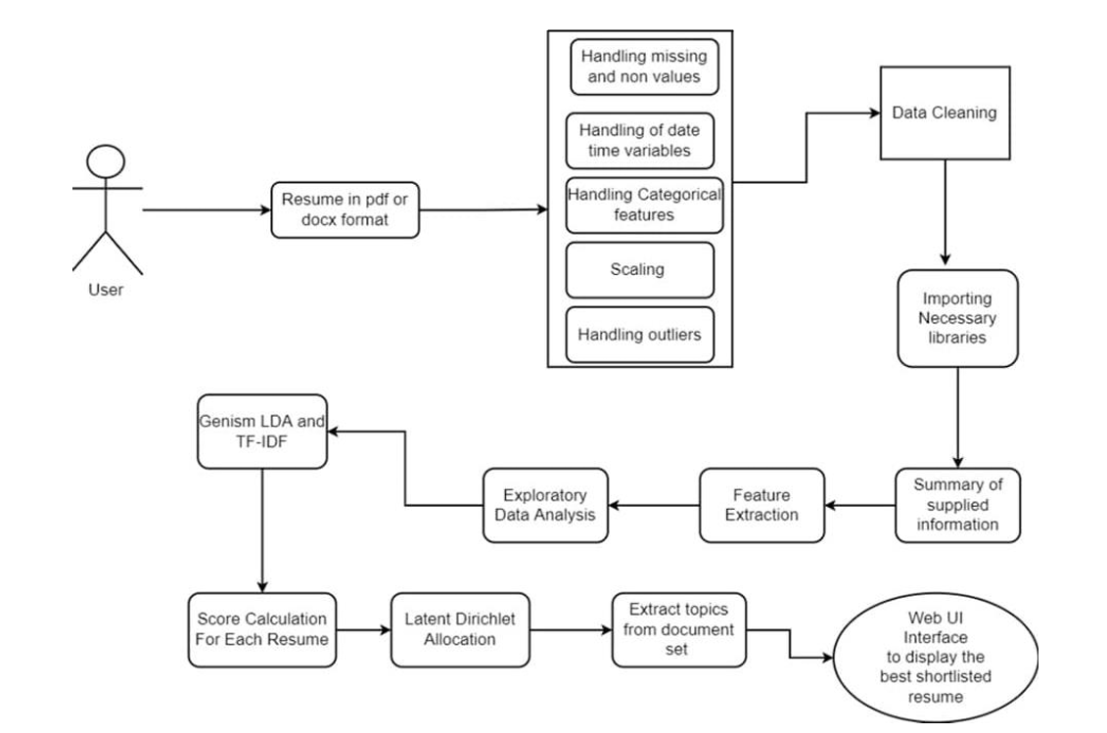

Fig: 3.1: Architecture Diagram

3.2 Use Case Diagram
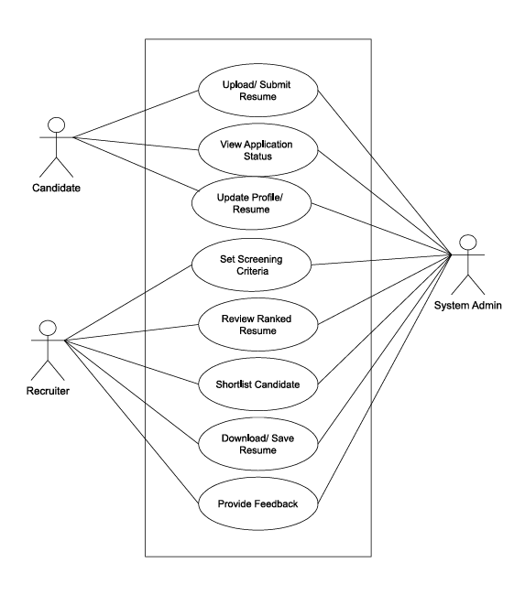
Fig: 3.2: Use-Case Diagram

3.3 Activity Diagram 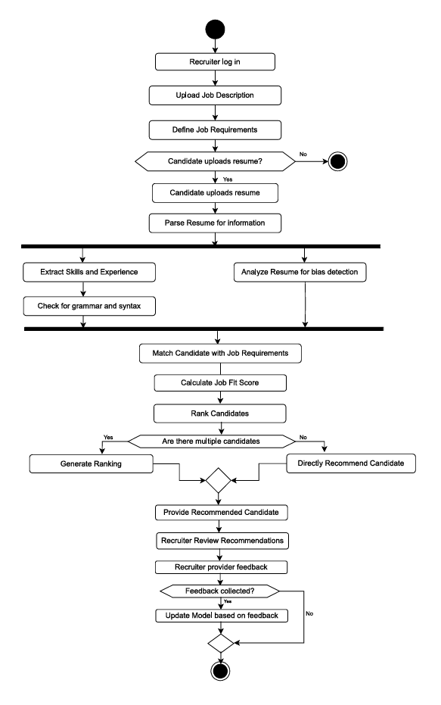
Fig: 3.3: Activity Diagram

3.4 Sequence Diagram
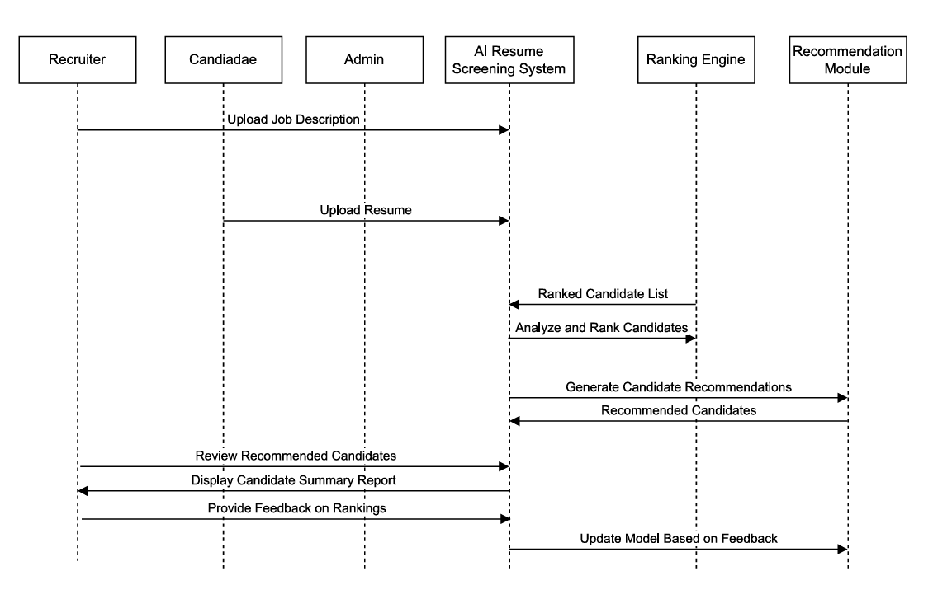
Fig: 3.4: Sequence Diagram

3.5 E-R Diagram
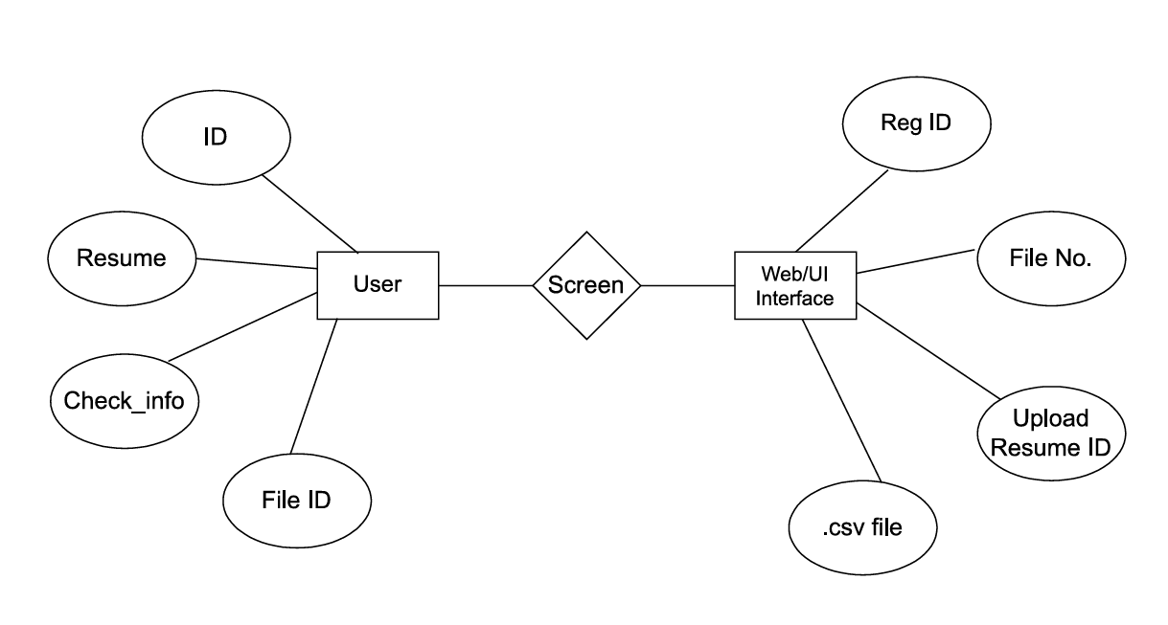
Fig: 3.5: E-R Diagram

3.6 Class Diagram

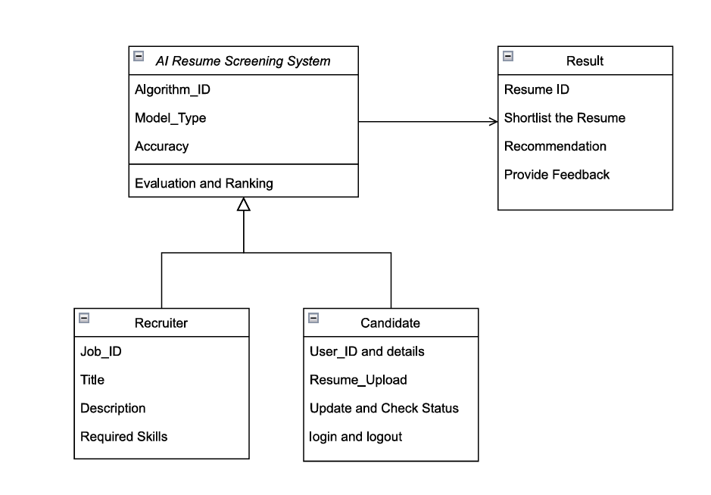
Fig: 3.6: Class Diagram
Chapter 4: Conclusion
The AI-Powered Resume Screening System represents a significant leap in streamlining recruitment processes by leveraging advanced technologies like Natural Language Processing (NLP) and Machine Learning (ML). This system is designed to efficiently analyze and rank resumes based on skills, experience, and job-specific criteria, significantly reducing the time and effort recruiters spend on manual screening. With features like resume parsing, candidate ranking, and intuitive dashboards, it offers an automated and data-driven approach to hiring.
The system enhances decision-making by providing detailed evaluation results, ensuring fairness and transparency in candidate selection. Additionally, it supports scalability, making it suitable for organizations of all sizes, from startups to large enterprises. By integrating robust security measures and maintaining compliance with data protection standards, the system ensures the confidentiality and integrity of candidate information.
This project has demonstrated the practical application of AI and database technologies in solving real-world challenges, showcasing their transformative potential in recruitment. However, as technology evolves, there remains ample room for improvement and expansion, paving the way for future developments.

Chapter 5: Future Scope
- Enhanced NLP Models: Use more advanced models like GPT for deeper insights into resumes.
- Video Interview Analysis: Integrate AI for analyzing candidate responses in video interviews.
- Skill Gap Analysis: Provide suggestions for skill development based on job requirements.
- Cross-Language Support: Enable resume screening in multiple languages.
- Cloud Deployment: Scale the system using cloud platforms for global accessibility.
- Integration with Job Portals: Link directly with platforms like LinkedIn or Indeed for streamlined candidate sourcing.
- AI-Based Decision Support: Offer recommendations for job-role matching and hiring trends based on market data.

References
- Journal:
  - J. Smith, "Artificial Intelligence and Recruitment: A Data-Driven Approach," Journal of Human Resource Analytics, vol. 5, no. 2, pp. 101-115, 2020.
- Book:
  - A. Brown and P. Johnson, Natural Language Processing with Python, 2nd ed., O'Reilly Media, 2022.
- Conference:
  - R. K. Gupta, "Enhancing Recruitment Systems with Machine Learning Algorithms," in Proceedings of the International Conference on Artificial Intelligence and Applications, Dubai, UAE, pp. 231-238, Mar. 2021.
- Thesis:
  - S. Patel, "AI-Powered Recruitment Systems," Master's Thesis, Dept. of Computer Science, University of California, Berkeley, 2021.
- Website:
  - https://enhancv.com
  - www.jobscan.co
  - www.zety.com
- Journal:
  - M. Chen et al., "Automated Resume Screening Using Deep Learning Models," International Journal of Advanced Computing, vol. 14, no. 7, pp. 1456-1470, 2023.
- Book:
  - P. Kumar and T. Sharma, Database Management Systems, McGraw Hill, 2021.
- Conference:
  - K. Lee, "Efficient Algorithms for Candidate Ranking in Recruitment," in Proceedings of the IEEE Symposium on Computational Intelligence, Singapore, pp. 89-94, Dec. 2020.
- Thesis:
  - S. Williams, "Job Applicant Screening with AI," Doctoral Dissertation, School of Technology, MIT, 2020.

Appendix A: Project Activities and Report

Project Activities | Project details
Requirement Gathering | Completed (Nov 1 - Nov 5)
System Design | In Progress (Nov 6 - Nov 15)
Frontend Development | Not started
Backend Development | Not started
Integration and Testing | Not started
Final Report Submission | Planned (Dec 15 - Dec 20)

Appendix B: Team Members and Task

Team Members | Assigned Task
Team Leader | Planning and monitoring progress.
Frontend Developer | UI design and implementation.
Backend Developer | Database integration and API development.
Algorithm Specialist | NLP and ML algorithm implementation.

Appendix C: Features and Description

Feature | Description
Resume Parsing | Extract skills, experience, and qualifications from uploaded resumes.
Candidate Ranking | Rank candidates based on job-specific criteria.
Dashboard | Provide recruiters with a visual summary of candidates and job applications.
Notifications | Send updates to recruiters and candidates via email

